Platforms

Must be available to download on the Apple and Android applications stores

Technical Requirements

Database – Sql

Database Host – AWS

Language – C++

Application Requirements

The application will have the following views

Login

Signup

Main view

Site view

Login View

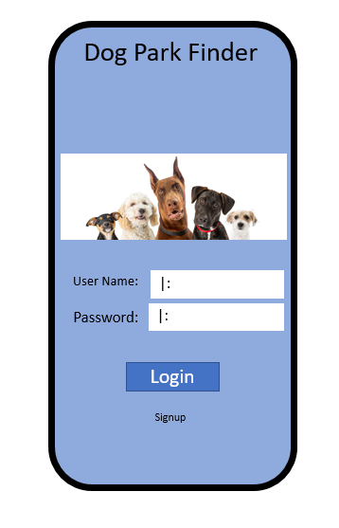

Fig 1 Login View

**Requirements**

* Login button when clicked will check the username and password fields for content
  + An Error will appear if no content is detected
* Login button when clicked and fields are full will check the username field against the database
  + If username is not found an error will appear
* When a valid username is detected the password field will be sent to a hashing algorithm function
  + The returned hash is compared to the hash stored in the database
  + If hash compare fails an error is issued “Invalid Password”
* Once user name and password are validated the login button links to the main view
* Signup button once clicked will link to the Signup View
* Site art is represented in Fig 1

Sign Up View

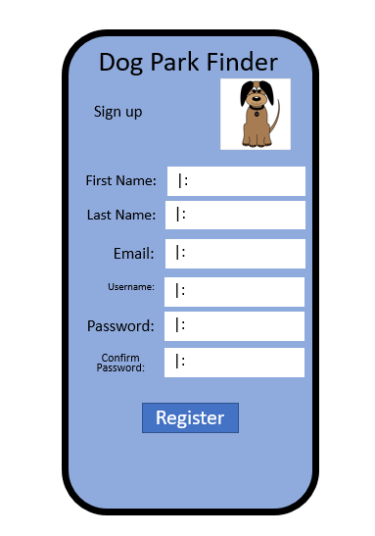

Fig 2 Sign Up View

**Requirements**

* The “First Name” field can only contain alpha numeric A-Z 1-9 characters
  + Special characters must be denied
  + If first name field is denied an error message will appear
* The “Last Name” field can only contain alpha numeric A-Z 1-9 characters
  + Special characters must be denied
  + If first name field is denied an error message will appear
* The “Email” field will be checked for valid .com extensions
  + An invalid extension will generate an invalid email error
* The “Email” field will be checked against the database
  + If the email is already in the database an error will be generated “Already registered”
* The “User Name” field will be checked against the database
  + If the User Name is already in the database an error will be generated “Username Taken”
* The “Password” field must contain at least a number and a special character and be at least 8 characters long
  + If the password entered does not meet the complexity required an error is generated “Complexity requirements not met”
* The “Confirm Password” field must match the “Password” field
  + If the “Password” and “Confirm Password” don’t match an error is generated “Passwords don’t match”
* The once the “Password” and “Confirm Password” match the password field is sent to a hashing function.
  + The returned hash is saved in the database as the password
  + Plain text passwords cannot be stored.
* When the register button is clicked and all the fields are deemed valid the user is created and saved into the database.
* Once user account is created the user will be linked to the main view
* Site art is represented in Fig 2

Main View

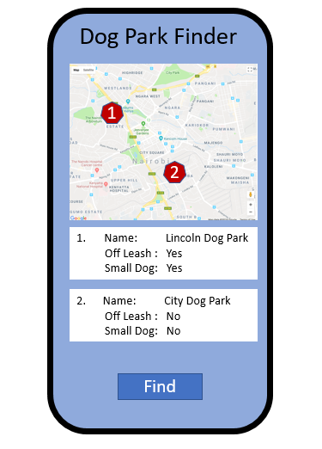

Fig 3 Main View

**Requirements**

* The find button when clicked will pull the devices GPS location
  + Location permissions must be granted to the application on the device
* When GPS location is known, the map is centered to the relative position on the device
* The Google earth API will be used to pull map imagery and dog park locations.
  + Is the above requirement possible?
* When dog parks are discoverable a scrollable list is placed at the bottom of the application refer to Fig 3
  + Each list tab will display
    - Dog Park Name
    - Off leash status
      * Displays yes, no or Unavailable
    - Small do park
      * Displays yes, no or Unavailable
* Once dog pack tab is clicked the user will be linked to the site view
* Site art is represented in Fig 3

Site View

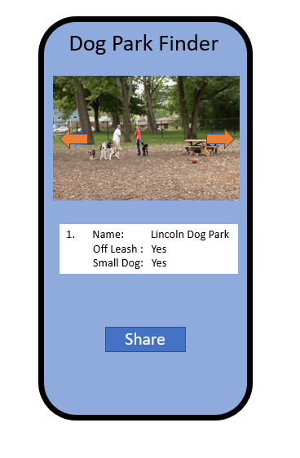

Fig 4 Site View

**Requirements**

* The site view will display pictures of the dog park if available
  + Dog park pictures are fetched from the database and displayed one at a time. Refer Fig 4
  + Multiple pictures can be scrolled through by clicking the Right and Left buttons
  + Picture scroll buttons are overlayed over the dog park image
* Below the dog park image, the dog park information is displayed
  + Each list tab will display
    - Dog Park Name
    - Off leash status
      * Displays yes, no or Unavailable
    - Small do park
      * Displays yes, no or Unavailable
* The share button when clicked will display more options to share the dog park location
  + Copy location
    - What kind of location?
      * Application specific (Dog Finder)
      * Google Earth Link?
        + Is google earth link possible?
  + Share via text message
    - Permissions to the devices contacts and messaging must be enabled
  + Share via Facebook
    - Is the above requirement possible?
* Site art is represented in Fig 4